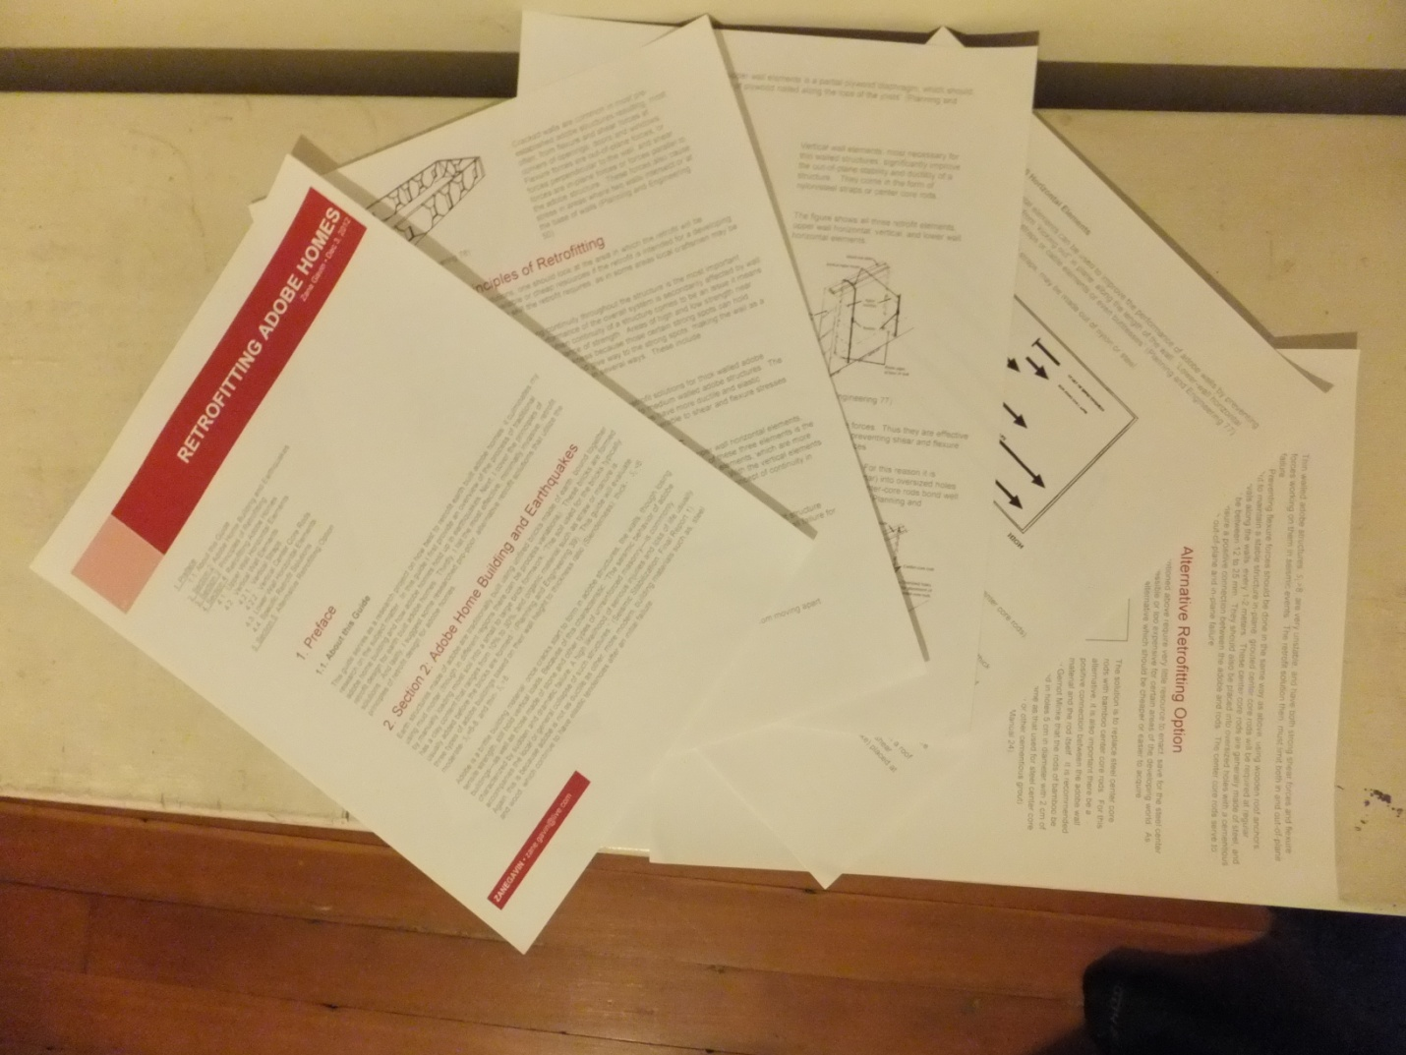

Earth Built Homes

A Guide to Retrofitting

# Table of Contents

Introductory Materials

Letter to Judges Page 3

Pre - Documentation

Letter of Intent Page 5

Product Planning Form Page 7

Research

Annotated Bibliography Page 8

Research Paper Page 13

Mentor Information

Mentor Handbook Page 30

Mentor Agreement Form Page 37

Mentor Log Sheet Page 39

Mentor Evaluation Page 42

Thank You Letter Page 44

Product Documentation

Supporting Evidence Page 45

Product Self - Evaluation Page 46

Product Page 48

Introductory Materials

Letter to Judges:

Zane Gavin

1214 Randolph Street, NE

Washington, DC 20017

April 27, 2013

Judges, Senior Project

School Without Walls SHS

2130 G Street, NW

Washington, DC 20037

Dear Judges,

Hello my name is Zane Gavin, and I chose to evaluate the practicality of adobe homes as an earthquake resilient housing option for the developing world.  My interest in this topic is rooted in my passion for engineering, science, and math. This academic passion has led me to take several challenging courses such as AP Physics, AP Calculus, and AP Human Geography.  Along with this rigorous academic experience, I also have more applicable real world experience in fields adjacent to my senior project topic: this includes a summer internship with a construction company (Heritage Restoration & Construction) and a service trip to appalachia (ASP), in which a crew of peers and I fixed up houses damaged by storms and floods.

I chose to do my project on utilizing adobe homes as an earthquake resilient housing option because it fit into my academic interests, as well as it being something I thought I would have a passion for.  It turned out I was right, I have learned so much about not only adobe and seismic building and retrofit, but I have learned about the developing world and the housing issues it faces.  My product, being a guide to building resilient structures with adobe, complimented my paper very well: the knowledge I gained from compiling and building my pamphlet aided tremendously in the writing of the paper.  My position throughout the project remained that adobe homes are a sustainable earthquake resistant housing option, thus my research paper backs up the usefulness of my pamphlet.

As aforementioned, my passion for this topic enabled me to go in depth and learn about how earthquakes affect the developing world, what building with adobe is like (its inherent strengths and weaknesses) and where the two meet. I learned that the developing world is struggling for an economically stable and suitable housing option and in some areas a housing option that needed to be able to withstand an earthquake.  That is where my research on adobe came in - I learned that adobe structures, and earth buildings in general, are a very economically stable housing option yet they inherit some weaknesses from the materials they are made of - earth.  I learned of ways to negate these weaknesses, and put the compilation of these modifications into a pamphlet.

The main challenge facing me at the beginning of this project was determining the right scope for the Senior Project.  Initially I considered evaluating all types of earth built homes as housing options for earthquake prone areas of the developing world - this turned out to be far too broad. I then considered leaving out the earthquake part of the project, to just focus on providing cheap homes to the developing world.  This option turned out to be too specific, and not very interesting.  I found the middle ground addressing areas of the developing world with adobe houses that could withstand earthquakes.  My success came with working with my mentor, she really helped me get in contact with people who would be able to help me.  Another success was my pamphlet, which is not only aesthetically pleasing, but very useful to the people to whom it was sent.

Thank you for your time and interest. I appreciate your participation on my review panel.

Sincerely,

Zane Gavin

Pre - Documentation

October 5, 2012

Christopher Alberts  
School Without Walls SHS  
2130 G. Street, NW  
Washington, DC 20037  
  
Dear Mr. Alberts,  
  
I am writing this letter to tell you more about me and my senior project.  The subject that I have chosen to focus on is the earthquake resilience of homes in developing countries.  First of all, this is a topic I am truly passionate about: to be able to do anything to help people injured or displaced by natural disasters is a more than worthwhile cause.  Secondly, this topic will serve to further my education because I look at the issue through a scientific perspective. The experience I have had with this topic is most closely associated with the physical aspects of construction as well as the planning that goes into it.  This past summer I participated in two activities that contributed to my understanding of the topic.  Early in the summer I went to West Virginia, where I worked with a non-profit called Appalachian Service Project (ASP) and renovated houses that were often damaged from storm or flood damage.  Later, I conducted an internship with Heritage Restoration and Construction, a construction company that essentially repurposes buildings and gives them new life.  I know I cannot expect the physical construction work to aid me with this project, but I can use the thought that goes into planning and organizing the work needed to get a construction job complete.  
  
In terms of research, databases that have been helpful to me are ProQuest and JSTOR. These databases have extensive filters that let the user discriminate the information provided.  In my case, research about building techniques and materials, as well as the impact of earthquakes on a region are the most pertinent sources.  My mentor also serves as a constructive primary source: she was once certified in seismic design and thus represents the exact type of expert to help me develop this project. To state my tentative thesis I first feel I must state my research question. It is as follows, how is earthquake building economically feasible in the developing world? My response to this would be, earthquake building, in developing countries, can only be feasible if the building makes inventive use of simplistic processes and local materials.  
  
For my product I intend to use knowledge I have gained from my research, my paper, and my mentor and construct an informative document that makes this knowledge accessible and applicable to those who need it most.  My product will address how to retrofit earth built homes to make them earthquake resilient with economic considerations. It should not be too difficult to use information I have gathered for my fifteen page research paper, or even my five page research paper, to lend me ideas on how to complete this product. For example, since my five page research paper was about earth built homes, I can start from there and pick models that make retrofitting possible, and develop economic solutions to retrofitting. This pamphlet would obviously be targeted at areas that do not have sufficient infrastructure to provide their citizens with this information, essentially areas of the developing world.  The costs for this product idea would be virtually nil; I may have to buy some sort of software so that this is in an aesthetically pleasing format, but it would not be an extensive cost.  The highest cost for this idea would most likely be the ink and paper needed to print copies of this, unless I decide to put it in another format, such as digital.  Considering the low-budget nature of this product idea, I will be able to cover all the costs associated with it from my pocket.  
  
When considering the completion of this project I know I must do it in a both efficient and original manner.  I know the consequences for not doing this are severe and could get me expelled from School Without Walls.  Even without consequences, the passion I have for this project topic outweighs the potential benefits of taking unethical shortcuts.    
  
Sincerely,

Zane Gavin  
1214 Randolph Street, NE  
Washington, DC 20017

Product Planning Form

|  |  |  |
| --- | --- | --- |
| Proposed Product:  Pamphlet on economically retrofitting certain homes to be earthquake resilient homes.  This pamphlet will be formatted in such a style that it addresses how to retrofit two different commonly used building styles to be more earthquake safe: it will deal with both the economics of the material and the necessary labor. My pamphlet will be submitted to up to ten relevant organizations/individuals and they will send me feedback on how useful the pamphlet is and what aspects of it need improvement. | | |
| Product Purpose:  Inform aid organizations, and individuals at these organizations, that homes in developing nations can be retrofitted to be earthquake resilient. Get feedback from these organizations on the effectiveness of the information and its layout. | | |
| Audience:  Developers in earthquake prone regions of the developing world and humanitarian, disaster relief and aid organizations. Specifically, CDM employee (Fairfax), CDM Pakistan Office, Engineers without borders, Habitat Humanity (Philipines), and other organizations from interaction aid members (Such as Build Change). | | |
| When: N/A – by Dec 13  Where: N/A - over the web | | |
| Mentor’s Role:  Suggest and help communication between me and above mentioned CDM offices. Suggest research on the materials and construction method most appropriate for earthquake building. Correct rough drafts and final drafts and check factual information. Aid in the making of the pamphlet – fine tuning the style, and choosing the most appropriate examples and wording | | |
| My Role:  Make an instructive pamphlet that has researched cost-durability/resilience analysis. Make communication with companies that will evaluate my pamphlet. | | |
| Materials Needed:  Physical Materials- Computer with templates for pamphlet. | | |
| Steps to Complete Product  (be as specific as possible) | Will be completed on | Comments |
| -Choose Template and house models that will be featured | 11/10/12 |  |
| -Make communication with aid organizations and send initial information | 11/17/12 |  |
| -Finish Pamphlet | 11/26/12 |  |
| -Send product to organizations/ individuals | 11/28/12 |  |
| -Receive Feedback (Hopefully*) | 12/8/12 |  |

Research

Adobe Homes: A Practical Housing Option

An Annotated Bibliography

Ginell, William S., and E. L. Tolles. "Seismic Stabilization of Historic Adobe Structures." Journal of the American Institute for Conservation 39.1 (2000): 147-63. International Bibliography of Art (IBA). Web. 20 Nov. 2012.

  This report, on seismic stabilization or seismic retrofit, does a quantitative review on the effectiveness of certain retrofit techniques: such as horizontal and vertical wall elements.  This information is made more valuable because of the use of scale models to demonstrate each respective wall element’s effectiveness.  The conclusion emphasizes one of the main concerns associated with the retrofit of Adobe homes: conserving the historical fabric of an Adobe structure while lessening the risk of “catastrophic collapse”.

Hawkey, Sean. "Building More Appropriately with Adobe Houses." *Appropriate Technology* 29.2 (2002): 58-9. *ProQuest Research Library; ProQuest Science Journals.* Web. 10 Jan. 2013.  
 This account reviews the housing crisis in El Salvador, after the civil war.  Sean Hawkey, a proponent of Adobe home building, worked with ex-guerrilla combatants  in an effort to house the many people made homeless by the El Salvadoran civil war.  He argues that for the same cost as a small concrete building, one could have a much preferable and larger adobe home.  Interestingly, these Adobe homes have one quality for which the ex-combatants were looking: they are bulletproof, unlike brick and block walled buildings.

Hui-Yuan, Hsieh, and John Forster. "Residential Construction Quality and Production Levels in Taiwan." Engineering, Construction and Architectural Management 13.5 (2006): 502-20. ProQuest Science Journals. Web. 16 Sep. 2012.  
 Hui-Yuan and Forster prove that construction quality (of homes) is directly influenced by the quantity of homes being built.  They study the 1999 earthquake that hit Taiwan, called Chi-Chi or 921, and reveal the complete havoc the earthquake inflicted on Taiwan - 15,000 deaths.  This extensive damage is attributed to the poor construction quality that characterized the construction sector of Taiwan in the 1990s called its “peak” years. The study articulates the importance of strict oversight of construction procedures, as well as the impact that the subcontracting to unskilled workers has on construction quality.

Minke, Gernot. "Earthquake - Resistant Houses: Construction Manual for Earthquake- Resistant Houses Built of Earth." Appropriate Technology 30.1 (2003): 64-. ABI/INFORM Complete; ABI/INFORM Complete; ProQuest Research Library; ProQuest Research Library. Web. 20 Nov. 2012.

Gernot Minke is head of the Building Research Laboratory in Germany, where he is also a professor and architect.  Additionally, he has written many books and over two hundred articles on the subject of earth building.  In this work, Minke evaluates various types of earth built homes (rammed earth walls, wattle and daub, and Adobe), but elaborates most extensively on Adobe home building.  Also enlightening in the work is the typical (earth building) design failures that Minke reviews.

Oliver, Paul.  “Earth as a Building Material Today” Oxford Art Journal , Vol. 5, No. 2,  Architecture (1983), pp. 31-38.  JSTOR Research Database. Web.  16 Sep.2012.

Paul Oliver, along with Gernot Minke, does well at evaluating the many kinds of earth built structures. Oliver reviews even clay lump and reinforced mud brick, methods that Minke fails to mention.  Oliver also, importantly, examines soil types that work well with these building methods.  He compliments this information with maps and pictures, which are valuable resources to demonstrate the prevalence of earth building in a world context.  These images would be equally valuable in a research paper - for the same reason.

Sanya, Tom. "Sustainable Architecture Evaluation Method in an African Context: Transgressing Discipline Boundaries with a Systems Approach." *Sustainability Science* 7.1 (2012): 55-65. *ProQuest Research Library; ProQuest Science Journals.* Web. 10 Jan. 2013.  
 This paper, based off of a PhD on sustainability of earth building in Uganda, reviews the sustainability of several earth building techniques centered on the sub-criteria: social, environmental, and economic.  It categorizes wattle and daub as the most sustainable building technique (of those studied) followed by Adobe, CEB, and Brick.  Sanya uses sustainability maps to evaluate each building technique, using the above mentioned sub-criteria, broken down into four sections each.  In the study, adobe did particularly well in regards to affordability, indoor environmental quality, job creation, and preservation of resources.

Taucer, Fabio, John E. Alarcon, and Emily So. "2007 August 15 Magnitude 7.9 Earthquake Near the Coast of Central Peru: Analysis and Field Mission Report." Bulletin of Earthquake Engineering 7.1 (2009): 1-70. ProQuest Science Journals. Web. 20 Sep. 2012.

The value in this source is the quantitative data it presents.  The study, in the Bulletin of Earthquake Engineering, analyzes the damage caused by the Magnitude 7.9 earthquake in Pisco, Peru.  The authors chose to focus specifically on non-engineered structures, such as Adobe homes.  The study also compares how well-retrofitted Adobe structures stood up as compared with their less engineered counterparts.

Tolles, E LeRoy, Edna E. Kimbro, Frederick A. Webster, and William S. Ginell. Seismic Stabilization of Historic Adobe Structures Final Report of the Getty Seismic Adobe Project. Rep. Illustrated ed. N.p.: Getty Publication, 2000. Web. 27 Nov. 2012.  
 This addition to the multitude of Getty Seismic Adobe Project works yields an especially detailed account of historic Adobe building and the risks often associated with it.  The work accompanies two other works, “Planning and Engineering Guidelines...” and another work of the same name, in evaluating Adobe retrofit techniques.  This work singularly diagrams the scale models and simulated damage attained in its preceding work.  It also introduces several concepts that the following study further investigates, such as the incidence of out of plane versus in plane failure.

Tolles, E. LeRoy, Edna E. Kimbro, and William S. Ginell, PH.D. Planning and Engineering Guidelines for the Seismic Retrofitting of Historic Adobe Structure. Rep. Illustrated ed. N.p.: Getty Publications, 2002. Web. 25 Nov. 2012.  
 The last work in the Getty Seismic Adobe Project (GSAP), this work is much denser than those preceding it. While about half of it covers specifically historic Adobe building, the rest of it is comprised of very rich and useful information. The authors first identify and explain typologies of earthquake damage to Adobe structures and then evaluate their amelioration. The retrofit techniques discussed in the work are stability based, around the two sub categories of in plane stability and out of plane stability. When evaluating retrofit techniques, they use three classification models based on slenderness: thick, moderately thick, and thin walled Adobe structures.

Zami, Mohammad Sharif, and Angela Lee. "Economic Benefits of Contemporary Earth Construction in Low-Cost Urban Housing - State-of-the-Art Review." Journal of Building Appraisal 5.3 (2010): 259-71. ProQuest Science Journals. Web. 16 Sep. 2012.

This article, by Zami and Lee, assesses the practicality of earthen structures in an urban environment. It starts off reviewing the general migration trend - people moving from rural to urban areas, and proposes earth built structures as an intelligent option to house the growing urban poor population. It cites that the inadequate use of cheap building materials leaves most urban poor homeless- unable to afford the available but expensive housing. The work reasons that earthen building can only be feasible in an urban environment where there is ample soil to build earthen homes, considering that transportation costs for materials into the city generally comprises about forty percent of total construction costs.

Zane Gavin

Mr. Alberts

Senior Project

March 1, 2013

Adobe Homes: A Practical Housing Option

Earthquakes are devastating and unpredictable acts of nature that seem to disproportionately affect the developing world, which is less suited to deal with the disasters.  Furthermore populations in these areas are starting to condense, posing more of a threat if an earthquake occurs near a city - as developing countries progress; their populations have a tendency to shift from rural to urban population concentrations for mostly economic reasons.  In fact the 7.0 magnitude earthquake that hit Haiti in 2010, killed over 300,000 people, the highest death count in the world since 1900 (“Earthquakes with 1,000...”).  The most damage from this quake was seen in Port-au-Prince, a major urban area of Haiti.  The rural to urban trend puts a strain on the local, developing world, governments to provide adequate infrastructure for the new population. Additionally it puts a strain on the construction sector, whether it is private or federal, to provide housing for the new urban residents.  Because the influx is rooted in jobs and pay, the new population is likely poor thus housing is targeted towards an underprivileged audience (Zami, Lee 259).  Additionally, these urban population shifts generally occur as the population booms putting a further strain on the building sector, as indicated by Hsieh Hui-Yuan in “Residential construction quality and production levels in Taiwan”, “the structural quality of construction falls, and falls measurably, as production reaches higher levels.” (516) This fall off in quality is measured primarily by the materials used as well as “construction management and process practices” (506).  All of this leads to the importance of easily accessible, affordable, and high quality buildings in earthquake prone regions.  It is the purpose of this paper to investigate the practicality of the building, and retrofit of current, adobe homes as a practical housing option, for earthquake prone zones of the developing world, because it can make inventive use of both simplistic processes and local materials.

Soil has been, and continues to be, the most widely used building material throughout most developing countries: it is cheap, available in abundance and simple to form into building elements (qtd. in Zami, Lee 260). Research shows however that earth buildings are extremely vulnerable to “seismic movement” (Oliver 31).  Additionally methods for making earth built homes, earthquake resilient are often complicated, as are the problems that go along with testing these homes.  Another problem that arises with earth building is that one cannot look at the problem generally; soils have different qualities in different areas.  Thus customized solutions are required for distinct regions on how to best earth build. These customized solutions are not solely dependent on the soil type of a region, as efficient earth building requires something supplementary to support the dirt and clay itself; solutions must include soil stabilization and/or structural reinforcement materials that are obtainable economically within a region.  But before that, earth building techniques must be specified and explained.  Mud itself  “ is a compression material; that is, it can take a considerable amount of vertical pressure and additional weight in the form of extra floors, timber joists, wood roofs and, often, several storeys.  [However] It has little or no tensile strength,” meaning that mud functions less well horizontally, such as in a storey, or a roof (Oliver 33).

There are a variety of forms of earth building, ranging from techniques such as wattle and daub to adobe, the most famous and the one discussed in this paper. The ‘Wattle-and-daub’ earth building technique makes use of the tensile strength of “wood withies and bark”; this aspect of the reinforcement is called ‘wattle’ (Oliver 33).  The ‘duab’ is made of clay, and is compressed to fit well over the ‘wattles’.  Another, more modern technique called ‘swish’ or ‘clay lump’, consists of  forming red lateritic soil into balls (half a meter in diameter), letting them dry then repeating the process until a full wall is complete.  The next is called ‘rammed earth’, rammed earth structures are built, as implied, by physically ramming or compressing moist soil until it accumulates necessary mass. Then the structure is reinforced with a wood frame, and the process is repeated. Generally, unless small stones are already present in the soil, pebbles and stones are mixed with in with the soil before the “ramming” process begins. Similarly, the soil used for cob walling contains a significant presence of pebbles and stones.  However ‘cob walling’ makes no use of wooden framework, cob wallers, much like rammed earth builders, compress the earth layer upon layer until the wall structure is complete. Lastly comes adobe: earth structures made of adobe are traditionally built using unfired bricks made of earth, bound together using some sort of mud mortar (though in different regions building practices are different). These bricks are formed by manually throwing moist soil into a small to large brick formwork. “The soil used for the bricks typically has a clay content that ranges from 10% to 30%, and organic material such as straw or manure is usually added before the bricks are formed” (Kimbro et al. 39).

The driving force between using the variety of earth building techniques is the soil that is available in a certain region, followed by the economic attainability of excess materials.  Paul Oliver categorizes the earth building regions into three main soil types, those with a high ratio of sand to clay, those with stones and pebbles mixed into the mud, and those with mostly homogenous clay and mud content.  Correspondingly, each of these soil types have certain techniques of earth building best suited for them, consequently there are three sets of techniques.  For the soil with high sand content, adobe bricks are the most appropriate methods of earth building.  Today, these methods are used in the American southwest, Central America, Northern Africa and Southern Europe.  Soil with higher pebble and small-stone content, is advantageous for the clay lump and rammed earth building techniques.  Areas that use this technique are western Africa, India and China.  Lastly, soil with homogeneous mud and clay content is best suited for reinforced mud and wattle and daub techniques.  The regions that make use of these techniques are northern South America, central Africa, and southeast Asia.  Though some areas are auspicious for earth building, there are reasons for a region not to earth build.  The primary reason being that there are other materials in abundance, such as “timbers and broad leaves [that] take precedence over mud for building” (Oliver 35). Adobe earth building was chosen as the focus of this paper because research has found that adobe is a more common building type in “some of the world’s most hazard-prone regions, such as Latin America, Africa, the Indian subcontinent and other parts of Asia, the Middle East, and southern Europe” (Blondet and Garcia 1).

Construction sectors in the developing world are characterized by boom and bust like surges, which studies on the subject show tend to cause a decline in the quality of what is being built. The rural to urban migration trend is a major factor in the unpredictability of the construction sector, and the general degeneration in condition of newly built homes. One study that affirms such claims is “Economic Benefits of Contemporary Earth Construction in Low-Cost Urban Housing”, by Zami and Lee. In this study they assert that the large influx of people into urban areas creates a demand for housing: some of which can be satisfied, but the majority of the population, being poor, cannot afford to buy available housing options. They argue that the cause of this is the inadequate use of cheap building materials (259).

In another study, “Residential Construction Quality and Production in Taiwan”, by Hsieh and Forster, they emphasize the importance of strict oversight of construction procedures, as well as the impact that the subcontracting to unskilled workers has on construction quality. Hsieh and Forster prove that construction quality (of homes) is directly influenced by the quantity of homes being built.  They study the 1999 earthquake that hit Taiwan, called Chi-Chi or 921, and reveal the complete havoc the earthquake inflicted on Taiwan - 15,000 deaths.  This extensive damage is attributed to the poor construction quality that characterized the construction sector of Taiwan in the 1990s called its “peak” years. Although Taiwan has strict laws controlling construction – to make homes and buildings as earthquake-resilient as possible – the study articulated that despite this, quality was still the major factor contributing to the magnitude of the damage done.

Other factors exist, that cause a decline in quality. The Construction Research Institute (CRI) identifies the following as the main determinants of damage due to earthquakes, “construction regulations; architectural designs; structural miscalculations; construction management; construction processes; and material quality” (Hsieh and Forster 506). Additionally, Taucer Alarcon, and So make the strikingly true statement that,

No matter how well an adobe house is constructed …an adobe house is bound to collapse in a sudden, brittle manner. Improving construction techniques, geometry, detailing and arrangement of walls … only retards their collapse, as shown by some adobe houses, especially farther away from the epicenter, with lower storey heights … and/or better quality construction … that did not collapse or sustained only limited damage (23).

Taucer, Alarcon, and So are uniquely qualified to discuss the subject of the quality of adobe homes, as they studied the the Magnitude 7.9 earthquake in Pisco, Peru focusing specifically on the damage done onto non-engineered structures, such as adobe homes.  The study also compares how well retrofitted adobe structures stood up as compared with their less engineered counterparts, a subject this paper addresses later. When doing their study they found that 80% of adobe homes collapsed (23). They attributed the collapse of these adobe structures to three attributes of adobe,

Heavy mass, thus inducing large inertial forces from the earthquake, Very low strength with respect to the density of the material (among the lowest of all construction materials), Failure of the material in a brittle manner, thus not allowing for energy dissipation and giving no warning to occupants before collapse (23).

Some other factors that Taucer, Alarcon, and So made mention of are related to the ineptitude of those who built the homes: low quality mortar, and the large amount openings.

Adobe structures are simply more affordable than structures made of modern building materials. The reason for this is that building with adobe, as well as making adobe bricks, requires minimal skilled labor, and can be done on a self help basis. An optimal example of this is Sean Hawkey, a major proponent of adobe building and the founder of a project that housed El Salvador. He points out that before there were “skyscrapers and shopping malls” there were adobe homes, and that 95% of El Salvadoran homes were built by their residents – an astounding feat. Sean Hawkey’s role in El Salvador was essentially a reconstruction effort: to house those made homeless by the El Salvadoran civil war. He showed people pictures of two houses of equal cost, one very large house made of adobe and a smaller house made of concrete – to help individuals visualize how economical adobe houses turned out to be. His project was a success; it was conceptually centered on ‘helping people help themselves’: laying the foundations for the construction and process, and including the family in the building process. Zami and Lee agreed with this assertion, “Adam and Agib (2001) also noted that block-making can be carried out on a ‘self-help’ basis, whereby labour costs are eliminated and soil is often available at no cost” (Zami and Lee 262).

Economic conditions that influence earth building are as follows: types of soil available for use, prices of the building materials, and current labor costs (Zami and Lee 261).  Following along these lines, “in Zambia, housing using conventional materials (brick, concrete) is too expensive for the majority of urban areas where transport amounts to approximately 40 per cent of the total material cost” (qtd in Zami and Lee).  Thus Zami and Lee conclude that it is more generally more practical to earth build in rural areas. What Zami and Lee also make note of in their article, “Economic Benefits of Contemporary Earth Construction”, that kept costs so low for earth construction, as compared with other methods were, rooted in “simplicity in process and dependence on local resources” (Zami and Lee 262). Simplicity of process lowers building costs because it requires less skilled builders, translating into cheaper workers or no workers at all, in the case of self-building. The dependence on local resources, means that the amount of imported materials is limited, lessening the overall cost of material transport. The economic viability of earth building in the developing world is also affirmed by Paul Oliver.  This economic suitability is imbedded in the point that in the developing world,

Mud, clay, earth or desert soil is abundantly available. With techniques that have been developed to suit the peculiarities of the differing soil qualities, and which have been refined in use over centuries, methods of building exist which exploit their potential (36).

Oliver makes the valid point that every area is not suitable for a specific type of earth building, such as adobe, or even earth building at all – such as areas with very low soil concentration – but that most of the inhabitable world does in fact have soil that is appropriate for one of the techniques that have, over time been developed. The developing world, which is the focus of this paper, does have the greatest amount of “desertic steppe soils” (the soil most applicable for adobe building), as Paul Oliver relates: covering the vast areas of Central America, northern Africa, and southern Eurasia (36).

Soil is an abundant natural resource, and although not all soil is suitable for adobe building, a fair amount of the developing world is covered in soil that is. One point, acknowledged by Paul Oliver reinforces the idea that the entire developing world has access to the materials that can be used to build an economically sensitive adobe home, due to the fact that the main building material generally comes at no cost to those building.

A …point of vital importance to the third world is that mud, clay, earth or desert soil is abundantly available. With techniques that have been developed to suit the peculiarities of the differing soil qualities, and which have been refined for use over centuries, methods of building exist which exploit their potential (Oliver 36).

This is reiterated by Zami and Lee, who pose “Soil has been, and continues to be, the most widely used building material throughout most developing countries: it is cheap, available in abundance and simple to form into building elements” (Zami and Lee 260).

One thing to make note of when building an adobe home is the naturally adobe is a brittle building material: once cracks start to form in adobe structures, the walls, though losing tensile strength, still hold vertical loads. Because of this, “The seismic behavior of adobe buildings…is commonly characterized by sudden and dramatic failure. A high likelihood of serious injuries and loss of life usually accompanies the local or general collapse of such structures” (Tolles et al. 1).

Again, this is because adobe is not as ductile as other, more modern, building materials such as, steel and wood, which continue to have elastic tendencies after an initial failure. Additionally, in adobe homes that are already built, cracked walls are common, resulting, most often, from flexure and shear forces at corners of openings, doors and windows. Flexure forces are out-of-plane forces, or forces perpendicular to the wall, and shear forces are in-plane forces or forces parallel to the adobe structure. These forces also cause stress in areas where two walls intersect or at the base of walls (Kimbro et al 50).

There are special considerations that must be acknowledged when retrofitting an Adobe home: “In the design of a retrofit system, providing continuity throughout the structure is the most important aspect of the design, and in general the performance of the overall system is secondarily affected by wall thickness.” (Kimbro et al 71) When continuity of a structure comes to be an issue it means there are certain areas where there is an imbalance of strength. Areas of high and low strength near one another on a wall, contribute to a wall’s weakness because those certain strong spots can hold vertical loads, but eventually the weak spots fail and give way to the strong spots, making the wall as a whole fail. The continuity can be affected/improved in several ways. These include upper wall horizontal elements, vertical wall elements, and lower wall horizontal elements. Thickness of an adobe wall also impact its resiliency: that retrofit solutions for thick walled adobe buildings should be less drastic than retrofit solutions for thin to medium walled adobe structures. The reason for this, in short, is because thick walled adobe structures have more ductile and elastic tendencies than their thinner counterparts, making them less vulnerable to shear and flexure stresses.

Again, the three elements that contribute to a structure’s continuity are upper wall horizontal elements, vertical elements, and lower wall horizontal elements. The most important of these three elements is the upper wall horizontal elements, followed by vertical and lower wall horizontal elements, which are more important for medium to thin walled structures than for thick walled structures. With the vertical elements it is important that they are placed at regular intervals in walls to establish that concept of continuity in the wall’s strength.

Upper wall horizontal elements are the most important retrofit elements for an adobe built structure because they help prevent walls from overturning- the most common type of wall failure for adobe structures. These elements: provide anchorage to the roof or floor, provide out-of-plane strength and stiffness, and establish in-plane continuity (Kimbro et al 75). The in-plane continuity aspect prevents cracks at the upper wall section from moving apart. The most economically viable upper wall elements is a partial plywood diaphragm, which should, “consist merely of a 4-foot width of plywood nailed along the tops of the joists” (Kimbro et al 76).

Vertical wall elements, most necessary for thin walled structures, significantly improve the out-of-plane stability and ductility of a structure. They come in the form of nylon/steel straps or center core rods. Vertical straps, most commonly made of nylon or steel, should be applied to both sides of the wall. Vertical center core rods are helpful in limiting both shear and flexure forces. Thus they are effective in every wall type: in the moderate and thin walls they are effective in preventing shear and flexure forces, and in thick walls they are solely useful for preventing shear forces. In using center core rods, it is important that they have a hold in the wall. For this reason it is recommended that center core rods are grouted (with epoxy or the like) into oversized holes so there is positive attachment between the rods and the wall. “Grouted center-core rods bond well to adobe because the grout material is absorbed irregularly into the adobe.” (Kimbro et al 76) “Lower-wall horizontal elements can be used to improve the performance of adobe walls by preventing cracked wall sections from “kicking out” in plane, along the length of the wall…Lower-wall horizontal elements can consist of straps or cable elements or even buttresses” (Kimbro et al 77). These elements, like vertical straps may be made out of nylon or steel.

The retrofitting solutions mentioned above, as a whole and relative to other housing options require very little resource to enact, the most expensive aspect being the steel required for certain retrofits such as the center core rods. A researched alternative to this option is to replace steel center core rods with bamboo center core rods, like the steel rods, it is important that there be a positive connection between the adobe wall material and the rods, therefore it is essential that the rods are grouted in oversized holes (Minke 24).

The “2007 August 15 magnitude 7.9 earthquake near the coast of Central Peru: analysis and field mission report” by Taucer, Alarcon and So, gave much support to the idea that unlike non-engineered adobe houses, reinforced adobe homes can stand up to seismic activity. They found that Adobe houses that were reinforced, either with “bamboo rods inserted inside of walls or as steel or polyester nets tied and plastered onto the surface of walls” suffered much less damage than those without (25).  Paul Oliver also listed examples, of ways to support earth built houses in the event of an earthquake, “Welded steel wire frames within poured mud walls, wooden ring beams to tie the walls, diagonal corner timbers and rod ties ay corner junctions all contribute to safety” (36).  Thus, even though earth built homes seem vulnerable during seismic activity, there are ways to support them that drastically increase the safety and structural integrity of the homes.

Another pull factor for making use of adobe homes in the developing world is the fact that adobe homes offer some natural (environmental) advantages that traditional building materials do not. Adobe homes offer a free of charge temperature equalizing service. As Paul Oliver puts it, “The thermal properties of earthen building are particularly agreeable, and especially suited to hot climates. Earth walls are not so much insulators as climate moderators: they tend to equalize temperatures” (34). This simply means that hot temperatures during the day are absorbed by the earthen structures, and help keep the structure warm at night.  Conversely, the cooling at night keeps the earthen houses cool during the hot temperatures of the day. Tony Sanya, in his paper about Ugandan homes including adobe and wattle and daub, found that adobe scored exceptionally well in the category of “Building Indoor Environmental Quality”.

Tom Sanya also reviews the sustainability of several earth building techniques centered on the sub-criteria: social, environmental, and economic. His paper, “Sustainable Architecture Evaluation…”, categorizes wattle and daub as the most sustainable building technique (of those studied) followed by adobe, CEB, and Brick.  Sanya uses sustainability maps (see figure 1) to evaluate each building technique, using the above mentioned sub-criteria, broken down into four sections each. As one can see in figure 1, adobe does particularly well in regards to affordability, indoor environmental quality, job creation, and preservation of resources, preservation of environmental quality, prevention of pollution, making for an overall well rounded sustainability map. Zami and Lee also investigate the sustainability of earth, as a building material, saying, “Experience has shown that earth remains a viable material, given costly increases in energy consumption caused by the production of modern building materials” (260). Along with the indoor quality of adobe homes, these details give another reason to support the building of adobe homes – their “green” aspect.

Figure 1 Adobe Sustainability Map

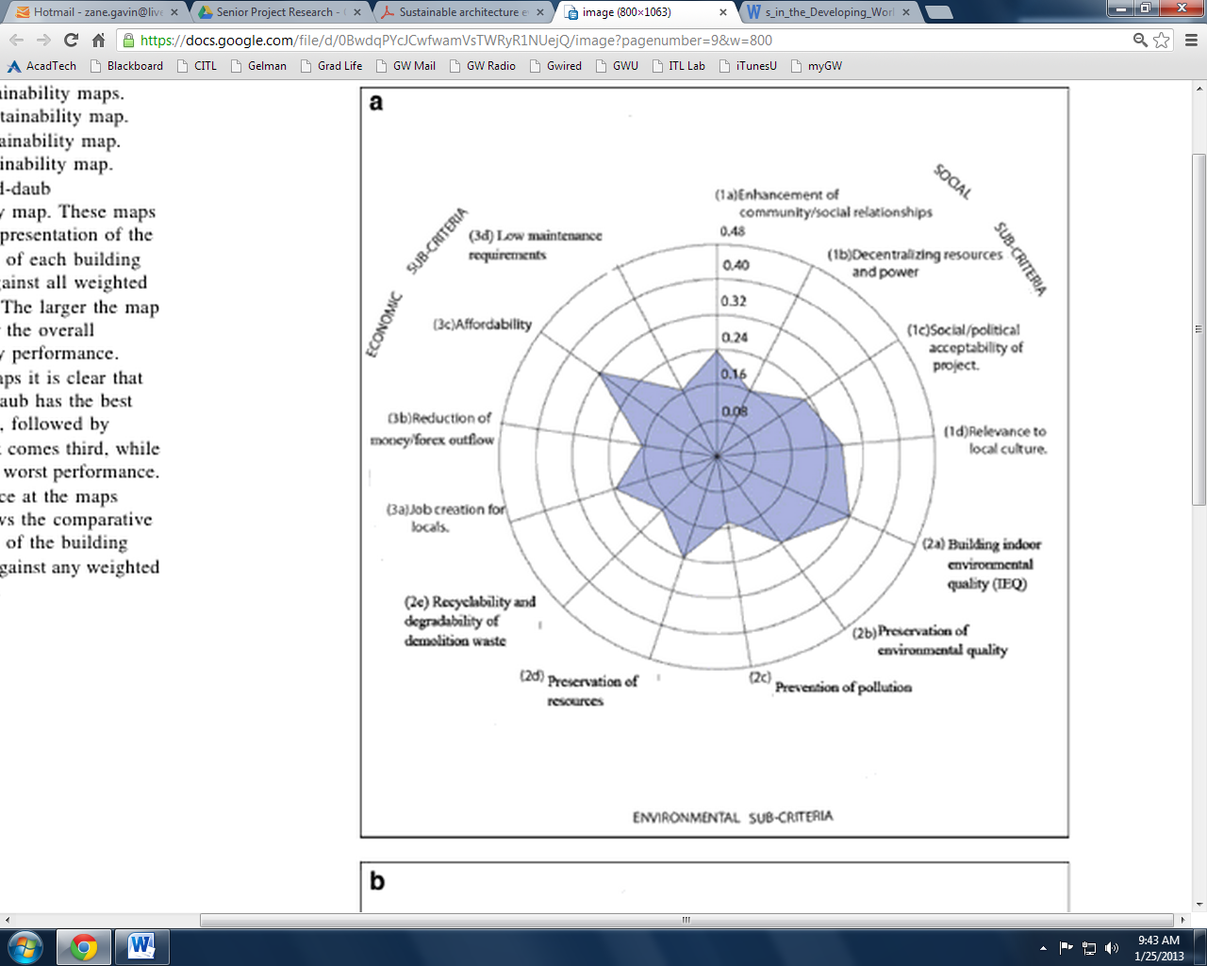

Fig. 1. Tom Sanya, "Sustainable Architecture Evaluation Method in an African Context: Transgressing Discipline Boundaries with a Systems Approach." Sustainability Science 7.1 (2012): 55-65. ProQuest Research Library; ProQuest Science Journals. Web. 10 Jan. 2013.

This paper reviewed the destructiveness killing power of earthquakes: the 2010 earthquake in Haiti ,which killed 300,000; the earthquake in Taiwan in 1999 killing 15, 000; and the earthquake in Peru – which because of its location caused fewer deaths, but inflicted extensive damage – demolishing 58,000 homes. This damage is rooted in the idea that there is a trend of people concentrating: moving into cities, so that when an earthquake’s epicenter is near a city that damage is amplified and much greater than it would have been if the population was dispersed. Another factor in this damage is that because there is a large rush of residents (mostly poor) into cities, the construction sector cannot possibly meet the demand and provide an adequate number of affordable homes, thus migrants are left to shantytowns – and if the construction sector does attempt to meet the demand they often bypass construction laws and build low-quality homes. This example is seen in Taiwan in the 1990s construction peak, investigated by Hsieh and Forster, where they found “evidence that suggests declines in construction quality occur at higher levels of production” (503).

These factors lead to the necessity of resilient and affordable homes for the developing world, especially in earthquake prone areas. Adobe homes are a perfect fit for that type of reconstruction, or any type of reconstruction - like that in El Salvador after the El Salvadoran civil war. While it is acknowledged that every soil type is not suitable for adobe building, a major portion of the developing world is covered in soil that is – this is especially true for seismically active areas. Additionally, non-engineered (in the case of this paper, un-retrofitted) adobe homes stand little chance of surviving in a strong earthquake, as seen with the earthquake that hit Peru in 1999. This earthquake destroyed 80% of non-engineered adobe homes (Taucer, Alarcon, and So 26). Moreover, when adobe walls fail they tend to do so out of plain and topple over, giving even more potential for killing. However, when Taucer, Alarcon, and So reviewed adobe homes with retrofit much like the ones described above (center core rods and vertical/horizontal ties), they found that the homes stood up exceptionally well as compared with their un-retrofitted analogues.

One must also note that adobe homes also offer the many pleasant pull factors that are independent of earthquakes and economy. These include: their sustainability, as well as their temperature equalizing service. Tom Sanya analyzes both the sustainability of different homes in Uganda as well as their properties of agreeable indoor environmental quality, where adobe did very well. Paul Oliver also offers input on the matter, agreeing with Sanya on the agreeable indoor environment of adobe homes

Overall this report affirms that earth built homes are economically viable for developing countries and that they have potential to sustain earthquake damage. The qualities that make these homes suitable economically for developing countries are “simplicity in process and dependence on local resources”. The earth building techniques aforementioned take little skill and equipment thus keeping the labor costs to a limit as well. The resilience of earth built homes, especially those made using adobe- sun burnt brick, came into question with the report by Taucer, Alarcon and So: though potential was mentioned for these doubts to be cast aside. This potential was in the form of reinforcement of earth built homes using wood or steel. So, although resilience to earthquakes was a disadvantage to earth built homes, the potential to provide additional support as well as the outstanding economic viability, and sustainability served as advantages to the use of earth built homes in developing countries.

Works Cited

Blondet, Marcial, and Gladys Villa Garcia, M. "ADOBE CONSTRUCTION." Thesis. Catholic University of Peru, n.d. Web. 24 Jan. 2013.

"Earthquakes with 1,000 or More Deaths since 1900." *Earthquakes with 1,000 or More Deaths since 1900*. N.p., n.d. Web. 20 Sept. 2012. <http://earthquake.usgs.gov/earthquakes/world/world_deaths.php>.

Ginell, William S., and E. L. Tolles. "Seismic Stabilization of Historic Adobe Structures." Journal of the American Institute for Conservation 39.1 (2000): 147-63. International Bibliography of Art (IBA). Web. 20 Nov. 2012.

 Hawkey, Sean. "Building More Appropriately with Adobe Houses." *Appropriate Technology* 29.2 (2002): 58-9. *ProQuest Research Library; ProQuest Science Journals.* Web. 10 Jan. 2013.

Hsieh, Hui-Yuan, and John Forster. "Residential Construction Quality and Production Levels in Taiwan." Engineering, Construction and Architectural Management 13.5 (2006): 502-20. ProQuest Science Journals. Web. 16 Sep. 2012.

Minke, Gernot. "Earthquake - Resistant Houses: Construction Manual for Earthquake- Resistant Houses Built of Earth." Appropriate Technology 30.1 (2003): 64-. ABI/INFORM Complete; ABI/INFORM Complete; ProQuest Research Library; ProQuest Research Library. Web. 20 Nov. 2012.

Oliver, Paul.  “Earth as a Building Material Today” Oxford Art Journal , Vol. 5, No. 2,  Architecture (1983), pp. 31-38.  JSTOR Research Database. Web.  16 Sep.2012.

Sanya, Tom. "Sustainable Architecture Evaluation Method in an African Context: Transgressing Discipline Boundaries with a Systems Approach." *Sustainability Science* 7.1 (2012): 55-65. *ProQuest Research Library; ProQuest Science Journals.* Web. 10 Jan. 2013.

Sanya, Tom. "Sustainable Architecture Evaluation Method in an African Context: Transgressing Discipline Boundaries with a Systems Approach." Sustainability Science 7.1 (2012): 55-65. ProQuest Research Library; ProQuest Science Journals. Web. 10 Jan. 2013.

Taucer, Fabio, John E. Alarcon, and Emily So. "2007 August 15 Magnitude 7.9 Earthquake Near the Coast of Central Peru: Analysis and Field Mission Report." Bulletin of Earthquake Engineering 7.1 (2009): 1-70. ProQuest Science Journals. Web. 20 Sep. 2012.

Tolles, E LeRoy, Edna E. Kimbro, Frederick A. Webster, and William S. Ginell. Seismic Stabilization of Historic Adobe Structures Final Report of the Getty Seismic Adobe Project. Rep. Illustrated ed. N.p.: Getty Publication, 2000. Web. 27 Nov. 2012.

Kimbro, Edna E., E. LeRoy Tolles and William S. Ginell, PH.D. Planning and Engineering Guidelines for the Seismic Retrofitting of Historic Adobe Structure. Rep. Illustrated ed. N.p.: Getty Publications, 2002. Web. 25 Nov. 2012.

Zami, Mohammad Sharif, and Angela Lee. "Economic Benefits of Contemporary Earth Construction in Low-Cost Urban Housing - State-of-the-Art Review." Journal of Building Appraisal 5.3 (2010): 259-71. ProQuest Science Journals. Web. 16 Sep. 2012.

Mentor Handbook (1)

Mentor Information



**School Without Walls’**

**Senior Project**

**Mentor Information Packet**

**2012-2013**

Mentor Handbook (2)

Dear Sir or Madam:

You have been chosen by _______________________________________, a student at the School Without Walls, to serve in the capacity of a mentor for his/ her Senior Project. By choosing you as a mentor, the student has determined that you are an expert on the specific topic that he/she is studying for his/her Senior Project. This four- part, year- long, student-driven, task consists of a research paper, project, portfolio, and presentation. As the culminating assignment of the student’s senior year, it is important that the project serve as a learning stretch for the student. Therefore, your guidance during the next three months is invaluable to his/her success.

By agreeing to mentor this student, you are committing to:

* Guide and encourage your mentee throughout the process;
* Meet with your mentee for a minimum of 10 hours between now and December 2012;
* Serve as a resource in the student’s field of interest;
* Assist your mentee with the development and creation of his/her project;
* Monitor your mentee’s progress and provide the student with feedback through face to face meetings and email correspondence;
* If your schedule allows, attend the student’s final presentation on April 26, 2013;
* Notify the Senior Project Coordinator, Jenine Pokorak, of any concerns with your mentee or the process;
* Complete the attached mentor information form;
* Complete a mentor evaluation form at the end of the process;
* Log the time spent with your mentee (a sample of this document can be found on page 5 of this handbook);
* Sign a dismissal form if it is necessary for your mentee to meet with you during the school day (a sample of this document can be found on page 6 of this handbook);
* Correspond with mentee’s Senior Project teacher to document student hours, professionalism, work ethic, and more.

Your mentee agrees to:

* Provide you with an initial letter outlining his/ her project and the Senior Project requirements (this should be a clearly defined topic on which the student will be able to write a 15-page, argument and thesis-driven research paper);
* Communicate with you in a timely fashion and on a regular basis to be determined by your mutual schedules;
* Be punctual and prepared for all appointments;
* Inform you of all important deadlines for forms and documentation throughout the process;
* Provide you with additional information should any changes to the Senior Project process or his/ her project become necessary.

Thank you for your commitment to this process and I look forward to working with you.

Sincerely,

Jenine Pokorak

E-mail: [Jenine.Pokorak@dc.gov](mailto:Jenine.Pokorak@dc.gov)

Phone: 202-645-9690

Mentor Handbook (3)

School Without Walls Profile

Purpose:

To cultivate a community of learners where adolescents seek to know who they are intellectually.

School Without Walls is a community of self-directed learners that engages District of Columbia adolescents in a rigorous high school program woven with substantive experiences based on the philosophy that life-long learning occurs both inside and outside the classroom. School Without Walls offers students intellectual and personal challenges leading to independent, intellectual inquiry combining academic excellence and responsible citizenship.

School Without Walls is a small District of Columbia public high school for grades 9-12. Besides ‘without walls’, this DC high school is also without boundaries, serving any DC teen. A truly urban setting, the student body represents every quadrant of DC. School Without Walls’ collegiate environment is a result of the long-term partnership with the university that has yielded many benefits for both communities.

Known to all as Walls, this community of motivated learners fosters formal and informal relationships among students, faculty, administration, families, George Washington University, and partners.

Wall’s mission is built upon values. From admissions and alumni outreach, to public service and international exchange, to performance on page, stage, and field, all activities are structured to foster creativity, curiosity, open-mindedness, love of learning, persistence, responsible global citizenship, and appreciation of excellence.

Typical Walls students go beyond what is expected. They demand more than pat answers to their questions. Walls’ students care about others and about their school. They value their independence and recognize the responsibilities associated with thinking and acting independently.

Above information taken directly from the School Without Walls website:

[www.swwhs.org](http://www.swwhs.org)

Principal: Richard Trogisch

Assistant Principals: Sylvia Isaac and Kelly Abbott

Location: 2130 G. Street, NW

Washington, DC 20037

Phone: 202-645-9690

Mentor Handbook (4)



Copies of Documents

For your Information



Mentor Handbook (5)

**School Without Walls**

2130 G Street, NW

Washington, DC 20037

202.645-9690

FAX: 202.724-8536

DISTRICT OF COLUMBIA PUBLIC SCHOOLS Richard Trogisch, Principal

<http://www.swwhs.org> Sylvia Isaac, Assistant Principal

Kelly Abbott, Assistant Principal

SCHOOL WITHOUT WALLS SHS

SENIOR PROJECT

MENTOR LOG

This form is to be completed by the assigned Senior Project Mentor and submitted directly from the mentor to the student’s Senior Project teacher by December 17, 2012. This form will be used to document a minimum of 10 hours during which the student met and worked with his/her mentor. The form may be sent digitally from the mentor to the assigned teacher or through the mail. The student is not to deliver this information to his/her teacher. Senior Project teachers will confirm the information submitted with the mentors following the December 17th deadline. At this time mentors will be asked to evaluate the progress of the student on the designed project.

Please make additional copies of this form as needed.

|  |  |  |  |
| --- | --- | --- | --- |
| Date: | Time student reported: | Time meeting concluded: | Mentor signature |
|  |  |  |  |
| Meeting’s objective and accomplishments: | | | |
| Date: | Time student reported: | Time meeting concluded: | Mentor signature |
|  |  |  |  |
| Meeting’s objective and accomplishments: | | | |

Mentor Handbook (6)

**School Without Walls**

2130 G Street, NW

Washington, DC 20037

202.645-9690

FAX: 202.724-8536

DISTRICT OF COLUMBIA PUBLIC SCHOOLS Richard Trogisch, Principal

<http://www.swwhs.org> Sylvia Isaac, Assistant Principal

Kelly Abbott, Assistant Principal

Senior Project

Dismissal form for mentor meetings

* If it is necessary for a student to meet with his/ her mentor during Senior Project class time, the following form must be completed and submitted to the assigned Senior Project teacher.
* This form must be given to the teacher **at least one week in advance** of the meeting.
* The form must be signed by the student, his/her mentor, and his/her parent/guardian.
* The information on the form will be verified by the assigned Senior Project teacher in advance.
* It is the student’s responsibility to confirm with his/ her teacher in advance that approval for missing class has been granted.
* Once the teacher has signed his/ her approval, a copy of this form should be submitted to the Attendance counselor.

Please excuse ________________________________________(student’s name) from class on ________________________ (date). He/ she will be meeting with his/her mentor from _____________ to _______________ (time) and at the following location ___________________________________________

___________________________________________________. The student understands that it is his/ her responsibility to make up all class assignments missed during this time.

The time with the mentor will be used for the following purpose:

______________________________________ __________________________________

Parent/ Guardian Signature Contact Information

______________________________________ __________________________________

Sr. Project Mentor Signature Contact Information

______________________________________ __________________________________

Student Signature Contact Information

Sr. Project Teacher’s Signature, indicating approval for dismissal ___________________________________

Signature of attendance counselor_______________________________________

Mentor Handbook (7)

Calendar of Deadlines for Senior Project 2012-2013

|  |  |  |
| --- | --- | --- |
| **REQUIREMENT** | **DUE DATE** | **COMPLETED** |
| Senior Project Contract | 9/7/2012 |  |
| 5 Page Report | 9/21/2012 |  |
| Interview with an expert | 9/28/2012 |  |
| Draft of Letter of Intent | 10/5/2012 |  |
| Mentor Agreement Form | 10/26/2012 |  |
| Letter of Intent | 10/26/2012 |  |
| Draft of Product Planning Form | 11/2/2012 |  |
| Product Planning Form | 11/9/2012 |  |
| Last day to submit a product change form | 11/26/2012 |  |
| 4 product/mentor update meetings with course instructor | 11/7/2012-12/7/2012 |  |
| Working Thesis | 12/3/2012 |  |
| Product due (and self evaluation) | 12/13/2012 |  |
| Product documentation through mentor  (Submitted directly from mentor to class instructor) | 12/17/2012 |  |
| Annotated Bibliography | 1/11/2013 |  |
| Paper Outline | 1/11/2013 |  |
| 1st Draft | 1/25/2013 |  |
| 2nd Draft | 2/8/2013 |  |
| Final Paper | 3/1/2013 |  |
| PowerPoint for Presentation | 3/22/2013 |  |
| Portfolio | 3/29/2013 |  |
| Presentation | 4/26/2013 |  |
| “Retakes”  (As needed) | As scheduled  4/29/13- 5/10/2013 |  |

Mentor Agreement Form (1)



Mentor Agreement Form (2)

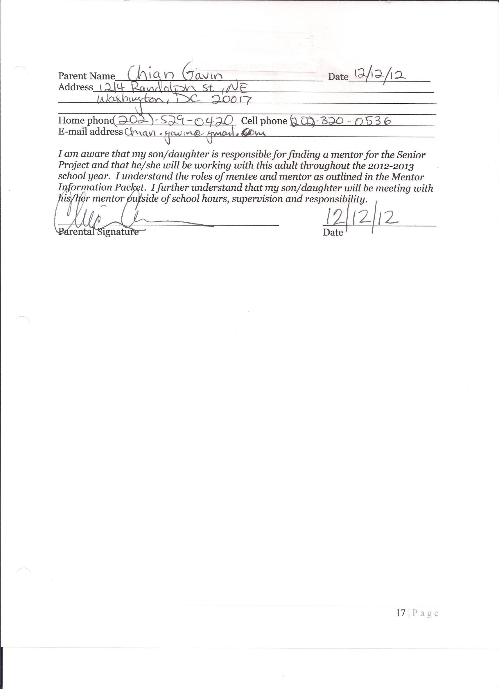

Mentor Log Sheet (1)



Mentor Log Sheet (2)



Mentor Log Sheet (3)



Mentor Evaluation:





Mentor Thank You Letter

December 12, 2012

Sarah Woodhead  
1242 Newton Street, NE

Washington, DC 20017

Dear Ms. Woodhead,

I would like to thank you immensely for all of your help conducting my senior project product. You have been influential in this experience since the beginning, shaping and changing my perceptions along the way. I know your schedule was and continues to be hectic and I appreciate your making time to help me in spite of this. You have been an indispensable source of information and guidance throughout this experience.

Specifically, I would like to thank you for playing an active role in helping shape my product topic. I started out thinking I would be making a very different product: a pamphlet that would address building earth built homes, not retrofitting them. I now see, through your suggestions, why the latter simply makes more sense. It is more practical; Earth built homes are already built - it is not economical to build new ones that are more earthquake resilient, it is however economical to retrofit built homes for seismic events. I would also like to thank you for your source suggestions and search topics, such as “pro-poor” design.

I cannot reiterate enough how thankful I am for your help in completing this product. I hope to remain in contact with you as I continue the senior project course, for I know your help will be as valuable on the paper as it has been on my product, as well as after the course. You have taught me so much, and without your help I never would have completed such a daunting project with such ease. Thanks again.

Sincerely,

Zane Gavin  
1214 Randolph Street, NE  
Washington, DC 20017

Product Documentation

## Supporting Evidence (these artifacts of evidence are in the attached folder)

Photo of Product

Email Correspondence with Mentor

Sarah Woodhead’s Evaluation

Anthony Papa’s Evaluation

Salman M. Khan’s Evaluation

Physical Evaluation from CDM and Smiths’ Fairfax Office

Notes (About Product) from Meetings with Mentor

Receipt from printing Product

Notes for Brochure from Sources

Self-Evaluation

This senior product is a pamphlet that serves to suggest retrofit methods to make earth built homes of Adobe earthquake resilient. I first gave an overview of Adobe home building, as well as how Adobe homes hold up in earthquakes. Next, I covered general retrofit principles for developing areas (i.e. local material, non-skilled labor, continuity throughout a structural system). Thirdly I provided specific examples of how to retrofit Adobe homes (i.e. upper and lower wall horizontal elements, and vertical elements), and gave retrofit solutions based on wall thickness (three scenarios). And lastly, I gave a researched cheap alternative one of the mentioned solutions (bamboo instead of steel).

About thirty hours worth of work went into completing this product. Broken down, ten of these hours would go to meeting with Ms. Woodhead (my mentor), about thirteen went into researching for the pamphlet (including pictures), and the last seven went to putting those resources into the pamphlet in a visually pleasing format.

Looking back on my product, if I were to redo something I think I would have tried to completed it earlier. If I had done so, I would have been able to get more evaluations and the evaluations that I currently have might be fuller.

The greatest strength of this product is the presentation format. I feel that this format really lends itself to reading comprehension, additionally evaluators found my use of images very helpful.

The greatest weakness of the product is its lack of background information. Many of my evaluators suggested I include some information about how prevalent earth built homes are in the world today, as well as how many are destroyed per year. I researched this, at the onset of my project, and I found very little hard facts on the subject matter. So I would say, although this was a weakness it is not really something I could have changed.

My grade - **Total: 28.5/30, 95% -** See next page

|  |  |  |  |  |  |
| --- | --- | --- | --- | --- | --- |
| **Criteria** | **EXCEPTIONAL**  **100 95 90** | **STRONG**  **89 85 80** | **PROGRESSING**  **79 75 70** | **WEAK**  **69 65** | **BELOW EXPECTATIONS**  **50** |
| **Product Goal**  **30%** | | | | | |
| **10%**  **10/10** | Receive Feedback from 4 or more individuals or organizations | Receive Feedback from 3 individuals or organizations | Receive Feedback from 2 individuals or organizations | Receive Feedback from 1 individuals or organizations |  |
| **10%**  **10/10** | The Feedback from individual/organizations suggests pamphlet is “exceptional” | The Feedback from individual/organizations suggests pamphlet is “strong” | The Feedback from individual/organizations suggests pamphlet is “progressing” | The Feedback from individual/organizations suggests pamphlet is “weak” | The Feedback from individual/organizations suggests pamphlet is “below expectations” |
| **5%**  **3.5/5** | There are minimal individuals/organizations suggest for improvement (>2) | There are some aspects individuals/organizations suggest for improvement (>3) | There are several aspects individuals/organizations suggest for improvement (>4) | There are many aspects individuals/organizations suggest for improvement (>5) |  |
| **5%**  **5/5** | There are less than two spelling or factual errors | There are three spelling or factual errors | There are four spelling or factual errors | There are five spelling or factual errors | There are six spelling or factual errors |
| **Total**  **28.5/30**  **95%** |  |  |  |  |  |

Feedback received from Mr. Khan, Ms. Woodhead, Mr. Papa, and the CDM and Smith Fairfax office (+ 10). Very little factual/formatting suggestions, suggestions mostly regarded style and questioned information (+10). There were suggestions, but again they were on style and there were less than four per organization/individual (+3.5). There were no factual errors suggested by evaluators, only questions about information (+5).

|  |  |
| --- | --- |
| v.1 | 1. Preface   * 1. About this Guide   2. Section 2: Adobe Home Building and Earthquakes  3. Section 3: Principles of Retrofitting  4. Section 4: Retrofitting Adobe Homes  4.1. Upper Wall Horizontal Elements  4.2. Vertical Wall Elements  4.2.1. Vertical Straps  4.2.2. Vertical Center Core Rods  4.3. Lower Wall Horizontal Elements  4.4. Specific Retrofit Solutions  5. Section 5: Alternative Retrofitting Options |

|  |  |
| --- | --- |
| v.1 | **RETROFITTING ADOBE HOMES**  Zane Gavin • Nov 28, 2012 |

## 1. Preface

### 1.1. About this Guide

This guide serves as a research project on how best to retrofit earth built adobe homes: it culminates my research on the subject matter. In this guide I will first give an overview of the process of traditional adobe home building and how adobe homes hold up in earthquakes. Next, I will cover the principles of retrofit design for earth built adobe homes. Thirdly, I will list the most effective, minimally invasive, retrofit solutions. And lastly, I will suggest some researched pro-poor, alternative retrofit solutions that utilize the principles of retrofit design for adobe homes.

## 2. Section 2: Adobe Home Building and Earthquakes

Earth structures made of adobe are traditionally built using unfired bricks made of earth, bound together using some sort of mud mortar (though in different regions building practices are different). These bricks are formed by manually throwing moist soil into a small to large brick formwork. “The soil used for the bricks typically has a clay content that ranges from 10% to 30%, and organic material such as straw or manure is usually added before the bricks are formed.” (Planning and Engineering 39). This guide will evaluate three types of adobe buildings based on their wall height to thickness ratio (Slenderness): thick- $S_{L}$ <6, moderate- $S_{L}$ =6-8, and thin- $S_{L}$ >8.

Adobe is a brittle building material: once cracks start to form in adobe structures, the walls, though losing tensile strength, still hold vertical loads. Because of this, “The seismic behavior of adobe buildings—as well as those made of stone and other types of unreinforced masonry—is commonly characterized by sudden and dramatic failure. A high likelihood of serious injuries and loss of life usually accompanies the local or general collapse of such structures.” (Seismic Stabilization: Final Report 1). Again, this is because adobe is not as ductile as other, more modern, building materials such as, steel and wood, which continue to have elastic tendencies after an initial failure.

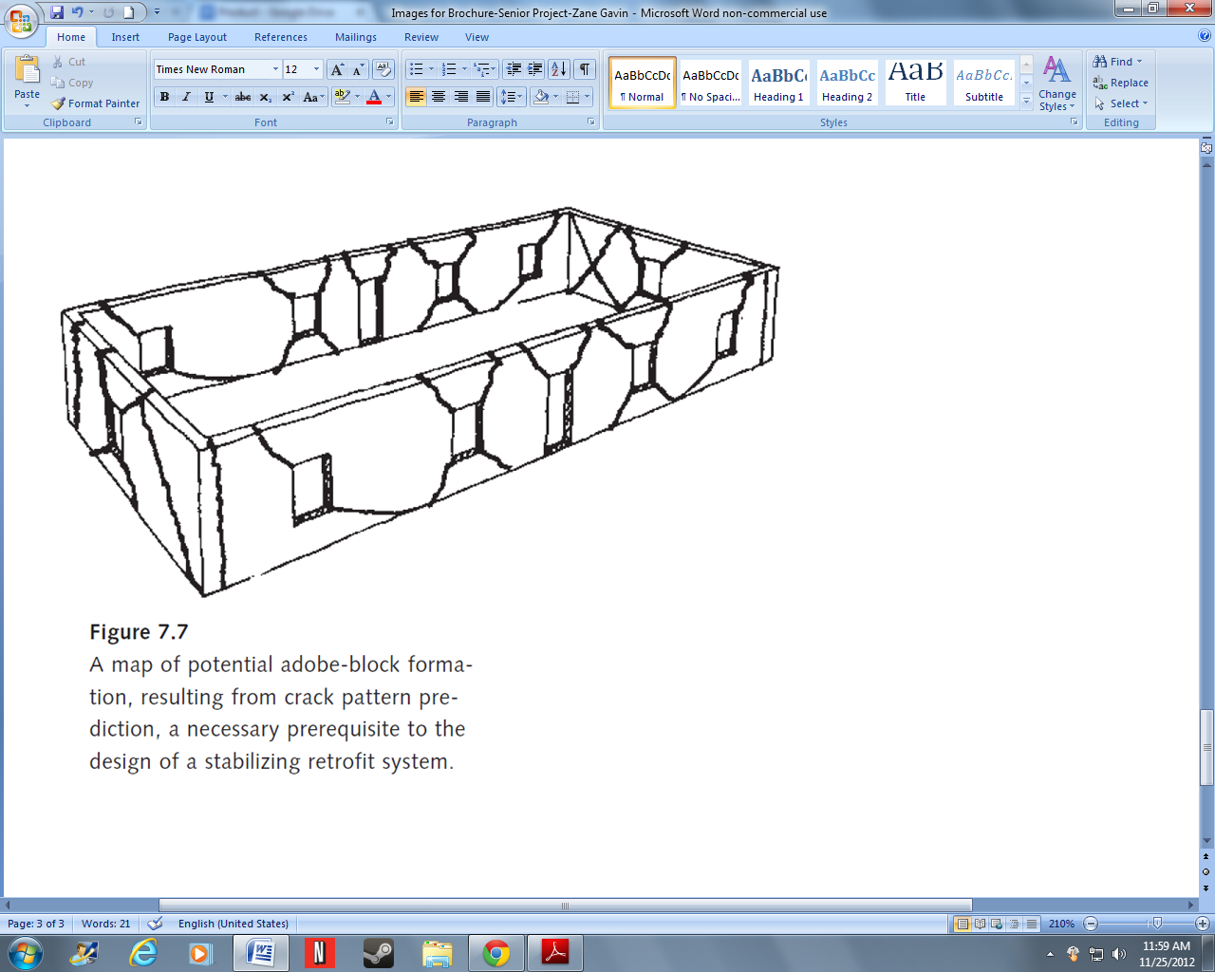

(Planning and Engineering 78)

Cracked walls are common in most pre-established adobe structures resulting, most often, from flexure and shear forces at corners of openings, doors and windows. Flexure forces are out-of-plane forces, or forces perpendicular to the wall, and shear forces are in-plane forces or forces parallel to the adobe structure. These forces also cause stress in areas where two walls intersect or at the base of walls (Planning and Engineering 50).

## 3. Section 3: Principles of Retrofitting

Whenever formulating retrofit solutions, one should look at the area in which the retrofit will be implemented. Consider locally available or cheap resources if the retrofit is intended for a developing area. One should also consider the skill the retrofit requires, as in some areas local craftsmen may be the only builders.

“In the design of a retrofit system, providing continuity throughout the structure is the most important aspect of the design, and in general the performance of the overall system is secondarily affected by wall thickness” (Planning and Engineering 71). When continuity of a structure comes to be an issue it means there are certain areas where there is an imbalance of strength. Areas of high and low strength near one another on a wall, contribute to a wall’s weakness because those certain strong spots can hold vertical loads, but eventually the weak spots fail and give way to the strong spots, making the wall as a whole fail. The continuity can be affected/improved in several ways. These include

• upper wall horizontal elements

• vertical wall elements, and

• lower wall horizontal elements.

Relating the thickness aspect to adobe houses means that retrofit solutions for thick walled adobe buildings should be less drastic than retrofit solutions for thin to medium walled adobe structures. The reason for this, in short, is because thick walled adobe structures have more ductile and elastic tendencies than their thinner counterparts, making them less vulnerable to shear and flexure stresses.

## 4. Section 4: Retrofitting Adobe Homes

Again, the three elements that contribute to a structure’s continuity are upper wall horizontal elements, vertical elements, and lower wall horizontal elements. The most important of these three elements is the upper wall horizontal elements, followed by vertical and lower wall horizontal elements, which are more important for medium to thin walled structures than for thick walled structures. With the vertical elements it is important that they are placed at regular intervals in walls to establish that concept of continuity in the wall’s strength.

### 4.1. Upper Wall Horizontal Elements

Upper wall horizontal elements are the most important retrofit elements for an adobe built structure because they help prevent walls from overturning- the most common type of wall failure for adobe structures. These elements:

• provide anchorage to the roof or floor

• provide out-of-plane strength and stiffness

• establish in-plane continuity

(Planning and Engineering 75)

The in-plane continuity aspect prevents cracks at the upper wall section from moving apart. The most economically viable upper wall elements is a partial plywood diaphragm, which should, “consist merely of a 4-foot width of plywood nailed along the tops of the joists” (Planning and Engineering 76)

### 4.2. Vertical Wall Elements

Vertical wall elements, most necessary for thin walled structures, significantly improve the out-of-plane stability and ductility of a structure. They come in the form of nylon/steel straps or center core rods.

The figure shows all three retrofit elements, upper wall horizontal, vertical and lower wall horizontal elements.

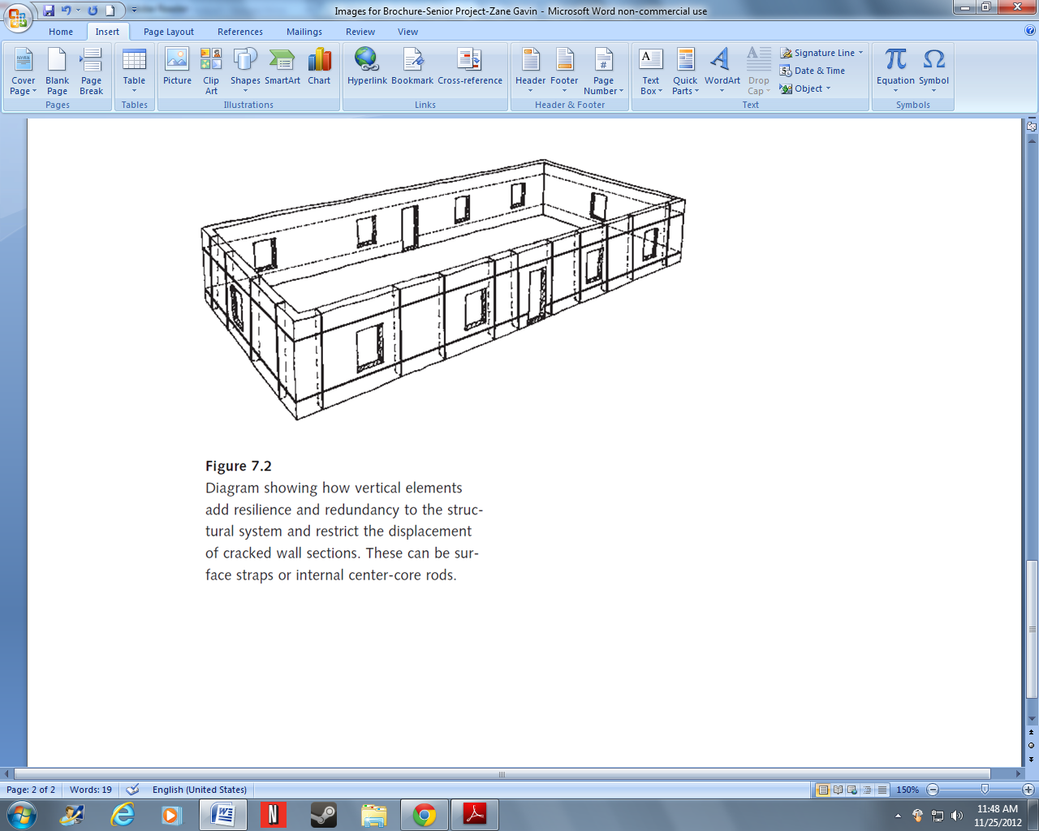

(Planning and Engineering 76)

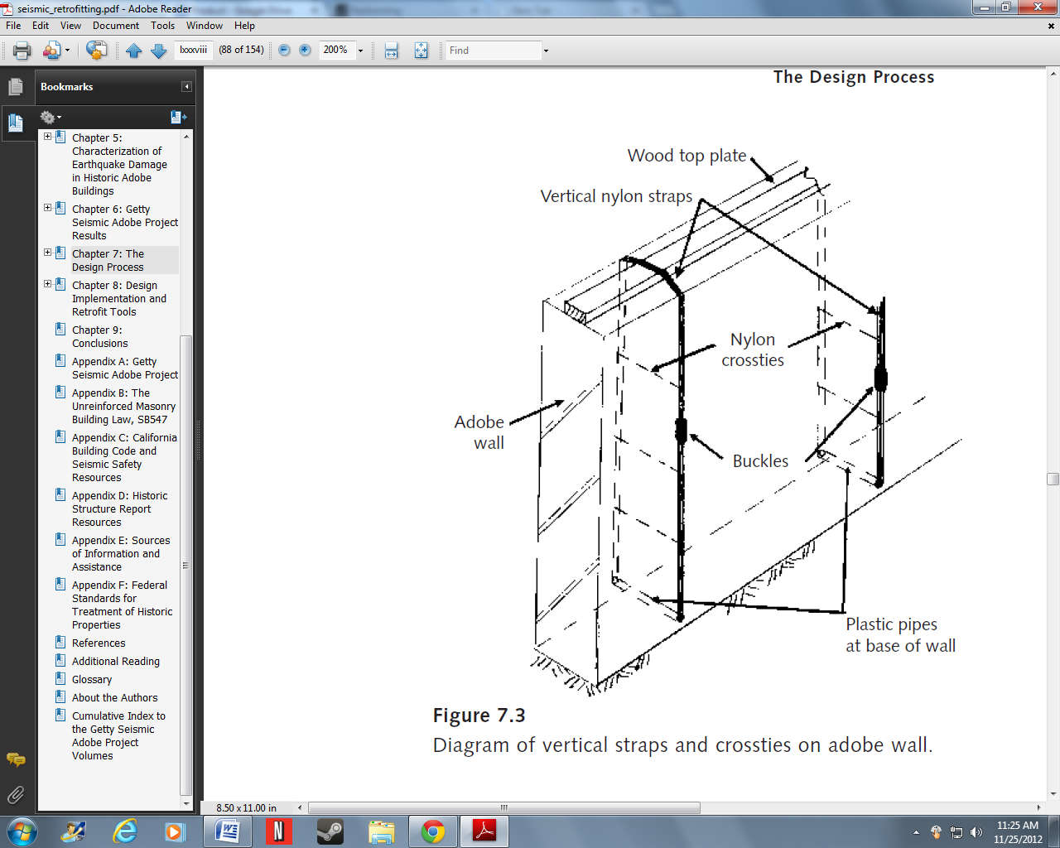

(Planning and Engineering 77)

**4.2.1. Vertical Straps**

Vertical straps, most commonly made of nylon or steel, should be applied to both sides of the wall. This retrofit option is most effective on moderate and thin walls.

#### 4.2.2. Vertical Center Core Rods

Vertical center core rods are helpful in limiting both shear and flexure forces. Thus they are effective in every wall type: in the moderate and thin walls they are effective in preventing shear and flexure forces, and in thick walls they are solely useful for preventing shear forces.

In using center core rods, it is important that they have a hold in the wall. For this reason it is recommended that center core rods are grouted (with epoxy or the like) into oversized holes so there is positive attachment between the rods and the wall. “Grouted center-core rods bond well to adobe because the grout material is absorbed irregularly into the adobe.” (Planning and Engineering 76)

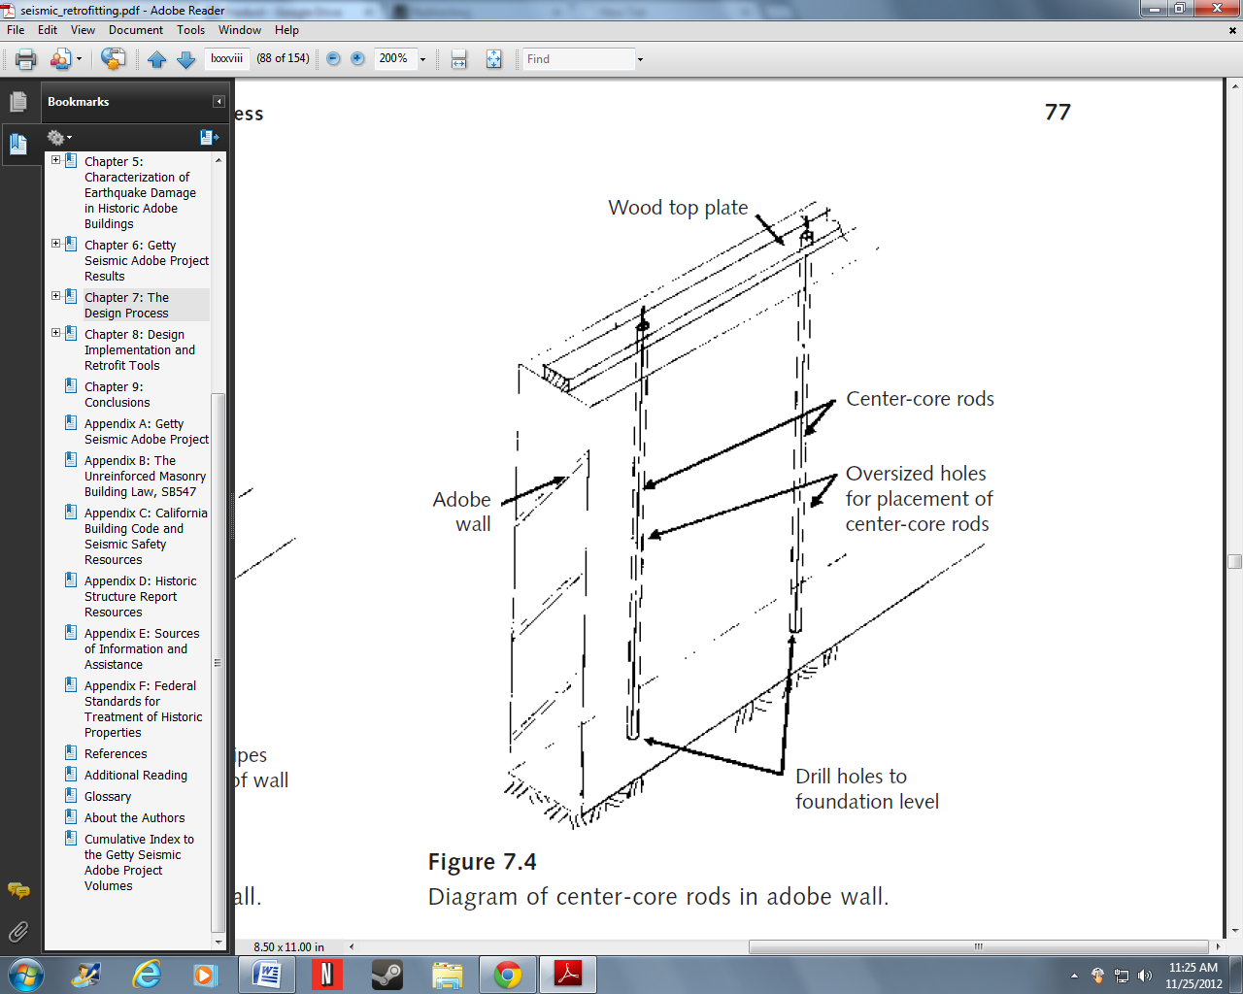

(Planning and Engineering 77)

“The diameter of center-core rods used in full-scale walls can range from 12 to 25 mm (0.5–1 in.), and the rods should be inserted in holes that are sized according to the needs of the material used for anchoring the center-core rods.” (Planning and Engineering 77)

As with the other elements, it is imperative that vertical center core rods be placed at regular and even intervals to ensure the continuity of the adobe wall, such as every 1-2 meters.

### 4.3. Lower Wall Horizontal Elements

“Lower-wall horizontal elements can be used to improve the performance of adobe walls by preventing cracked wall sections from “kicking out” in plane, along the length of the wall…Lower-wall horizontal elements can consist of straps or cable elements or even buttresses” (Planning and Engineering 77)

These elements, like vertical straps may be made out of nylon or steel.

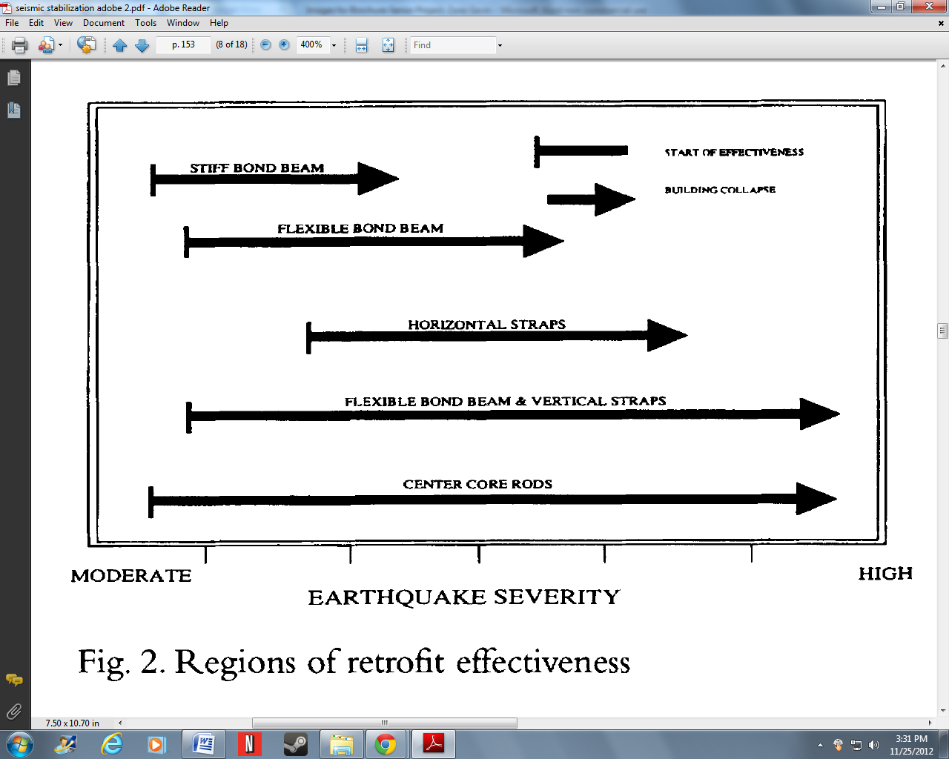

(Seismic Stabilization 153)

The diagram emphasizes the effectiveness upper wall elements (vertical straps and center core rods), and lower wall horizontal elements (horizontal straps).

### 4.4. Specific Retrofit Solutions

For thick walled structures, $S_{L}$ <6, the most important aspect of retrofit is roof anchors, because thick walls are still prone to overturning.

The retrofit solution, then, for a thick walled structure would include only roof anchors. These roof anchors should be in the form of a partial wood diaphragm- which in the minimum would “consist merely of a 4-foot width of plywood nailed along the tops of the joists” (Planning and Engineering 76). This system would limit flexure forces that act at the top of the massively heavy thick adobe walls.

Moderately thick walls, $S_{L}$ =6-8, are susceptible to both flexure and shear forces. The flexure forces working on a moderately thick walled structure are more prevalent than shear forces thus a retrofit solution must make use of preventative measures for both weaknesses, but primarily to address flexure forces.

To prevent flexure forces, the retrofit solution will include the upper wall horizontal element of a roof anchor (the same as described above). Secondarily important are the elements that limit shear forces. With moderately thick walls this should be vertical straps (steel, nylon, or the like) placed at regular intervals, such as every 1-2 meters.

Thin walled adobe structures, $S_{L}$ >8, are very unstable, and have both strong shear forces and flexure forces working on them in seismic events. The retrofit solution then, must limit both in and out-of-plane failure.

Preventing flexure forces should be done in the same way as above, using wooden roof anchors. But to maintain a stable structure in-plane, grouted center core rods will be required at regular intervals along the walls, every 1-2 meters. These center core rods are generally made of steel, and should be between 12 to 25 mm. They should also be placed into oversized holes with a cementious grout to ensure a positive connection between the adobe and rods. The center core rods serve to prevent both out-of-plane and in-plane failure.

## 5. Section 5: Alternative Retrofitting Options

The retrofitting solutions mentioned above require very little resource to enact, save for the steel center core rods, which may be inaccessible or too expensive for certain areas of the developing world. As such, I have included a pro-poor alternative which should be cheaper or easier to acquire.

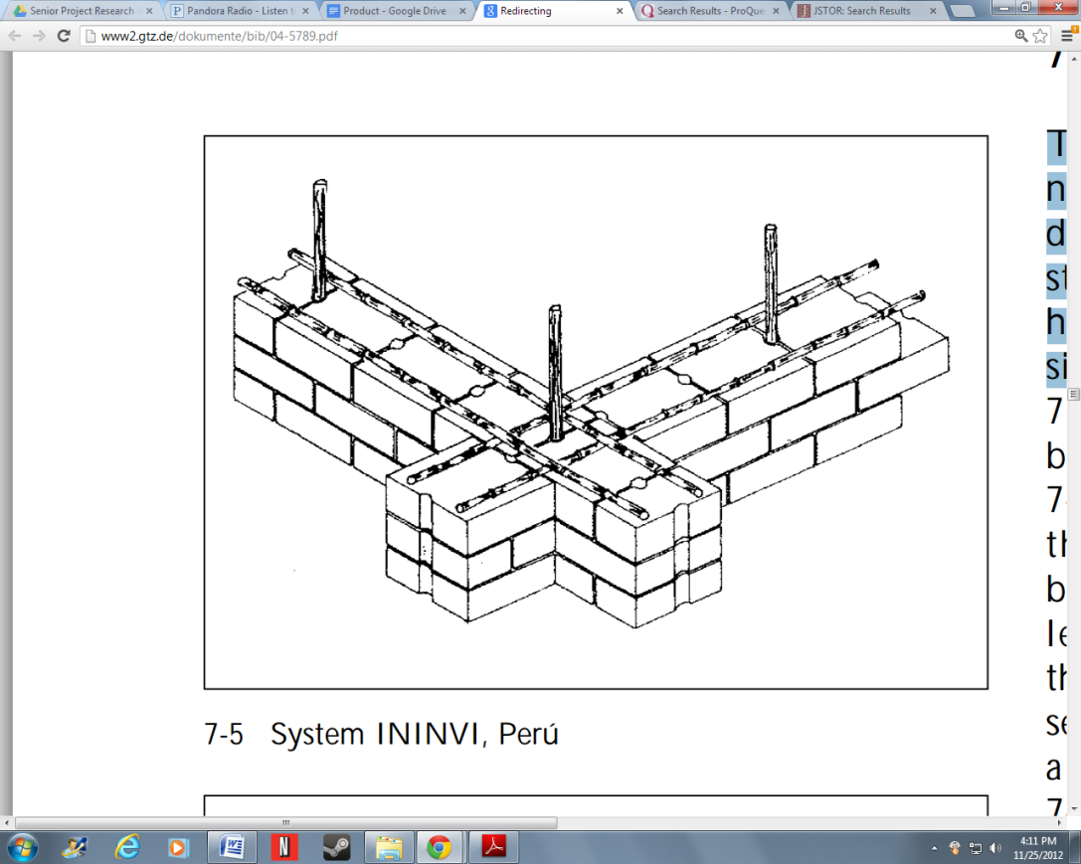

(Construction Manual 24)

The solution is to replace steel center core rods with bamboo center core rods. For this alternative, it is important that just like for the steel center core rods there be a positive connection between the adobe wall material and the rod itself. It is recommended by Gernot Minke that the rods of bamboo be placed in holes 5 cm in diameter with 2 cm of grout, same as that used for steel center core rods (epoxy or other cementious grout) (Construction Manual 24).

Works Cited

Minke, Gernot. *"Earthquake - Resistant Houses: Construction Manual for Earthquake-Resistant Houses Built of Earth.*" Appropriate Technology 30.1 (2003): 64-. ABI/INFORM Complete; ABI/INFORM Complete; ProQuest Research Library; ProQuest Research Library. Web. 20 Nov. 2012.

Ginell, William S., and E. L. Tolles. "*Seismic Stabilization of Historic Adobe Structures.*"  Journal of the American Institute for Conservation 39.1 (2000): 147-63. International Bibliography of Art (IBA). Web. 20 Nov. 2012.

Tolles, E. Leroy, Edna E. Kimbro, and William S. Ginell, PH.D. *Planning and Engineering Guidelines for the Seismic Retrofitting of Historic Adobe Structure*. Rep. Illustrated ed. N.p.: Getty Publications, 2002. Web. 25 Nov. 2012.

Tolles, E LeRoy, Edna E. Kimbro, Frederick A. Webster, and William S. Ginell. *Seismic Stabilization of Historic Adobe Structures: Final Report of the Getty Seismic Adobe Project*. Rep. Illustrated ed. N.p.: Getty Publication, 2000. Web. 27 Nov. 2012.